**JMeter Integration with Grafana + Influx DB for Real Time-Monitoring System**

**Tools required for the set-up**

* **Database:** Prometheus or Influx DB.
* **Graphing** **Tool**: Open Source Grafana
* **Testing** **Tool**: Opensource Apache JMeter

**Pre requisites**

* Apache JMeter should be installed
* JAVA latest version should be configured in the system
* Windows OS machine

**Install Influx DB**

**Step 1:** Download Influx DB from below link

<https://dl.influxdata.com/influxdb/releases/influxdb-1.8.0_windows_amd64.zip>

**Step 2:** Once the installation is done, open the Zip file and Navigate to influxdb.config file shown in below fig:1.0

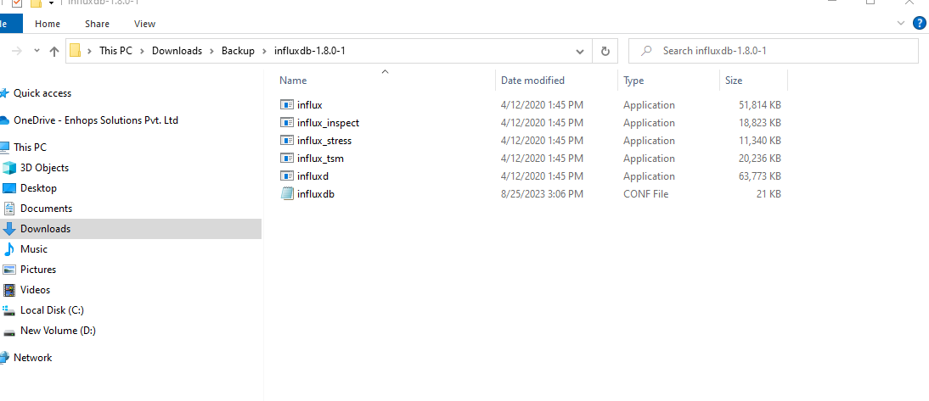

Fig:1.0

**Step 3:**

[meta]

# Where the metadata/raft database is stored

dir = "/var/lib/influxdb/meta"

[data]

# The directory where the TSM storage engine stores TSM files.

dir = "/var/lib/influxdb/data"

# The directory where the TSM storage engine stores WAL files.

wal-dir = "/var/lib/influxdb/wal"

[http]

# Determines whether HTTP endpoint is enabled.

enabled = true

# Determines whether HTTP request logging is enabled.

log-enabled = true

The bind address used by the HTTP service.

bind-address = ":8086"

[[graphite]]

# Determines whether the graphite endpoint is enabled.

enabled = true

database = jmeter

retention-policy = ""

bind-address = ":2003"

protocol = "tcp"

consistency-level = "one"

Fig:1.2

Fig:1.2

* Change the config setting as per fig 1.2 and save it.

**Step 4:**

* Launch the Command Prompt (Windows+R; Type cmd)
* cd C:\Users\Downloads\influxdb-1.7.9_windows_amd64\influxdb-1.7.9–1
* Type the below command to initiate the DB server and click ‘Enter’  
   influxd.exe -config influxdb.conf

Or

Open influx application as shown in fig1.0

* It shows in below fig 1.3

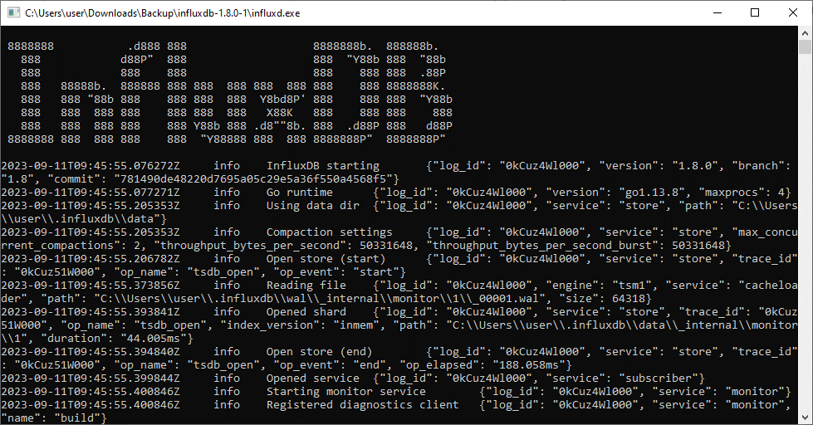

Fig:1.3

**Step 5:**

* Open the influx.exe file in fig 1.0 To create DataBase.
* Run the "**SHOW DATABASES"** command – this will give you a list of databases.
* Run the command: **"CREATE DATABASE JMeter_Demo"** - here "JMeter-Demo" is the database name
* Run **SHOW DATABASES** again and you should see your new database listed
* As shown in fig 1.4

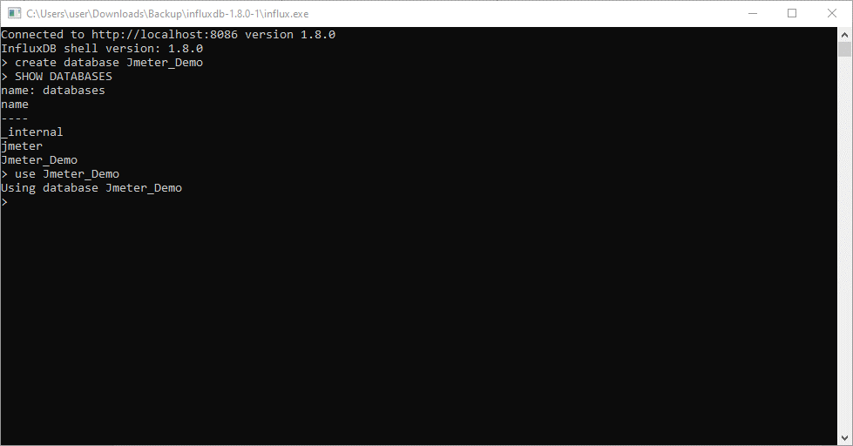

Fig 1.4

*We all set the InfluxDB.*

**2.JMETER SETUP:**

1. Install Jmeter
2. Create a TestPlan
3. Add Thread Group
4. Here I will be one my existing JMeter Test, we will see how to Configure the BackendListener to write metrix into influxDB
5. Add a new backend listener to the thread group. Right Click on a **Thread Group -> Add -> Listener -> Backend Listner**
6. It shown as given fig 1.5

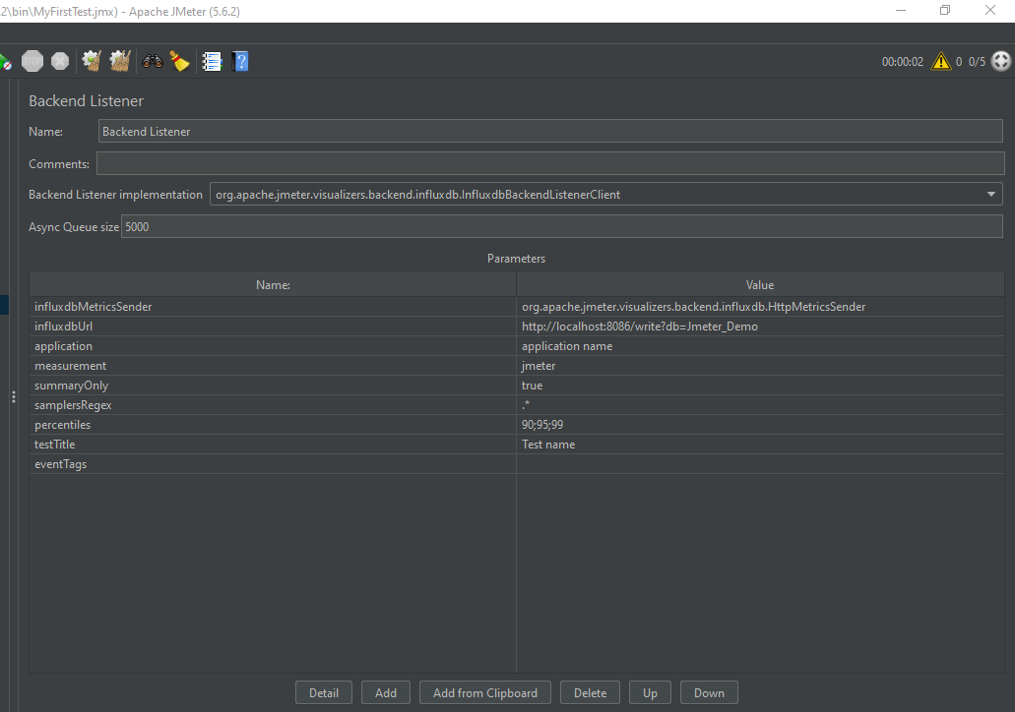

Fig 1.5

7: Set up config in Backend Listener to integrate with Influx DataBase

* **InfluxdbMetricsSender**– this is the class for sending metrics to InfluxDB. We will keep it as default.
* **InfluxdbUrl**– this is the URL of InfluxDB is in the following format: [http://%5Binfluxdb_host%5D:%5Binfluxdb_port%5D/write?db=%5Bdatabase_name%5D](http://[influxdb_host]:%5Binfluxdb_port%5D/write?db=%5Bdatabase_name%5D). As we have created the “**JMETER_Demo**” database and we are running it on a local machine with a default port, then, in our case, the URL will be <http://localhost:8086/write?db=JMeter_Demo>. **(Change the URL)**

**Here we set up the Listener in Jmeter**

Now, Go for Grafana..

**3.GRAFANA INSTALLATION**

**Step 1:** click on below link

<https://grafana.com/docs/grafana/latest/setup-grafana/installation/windows/>

* select 7.3.7 version and win as shown in fig 3.0
* and download it

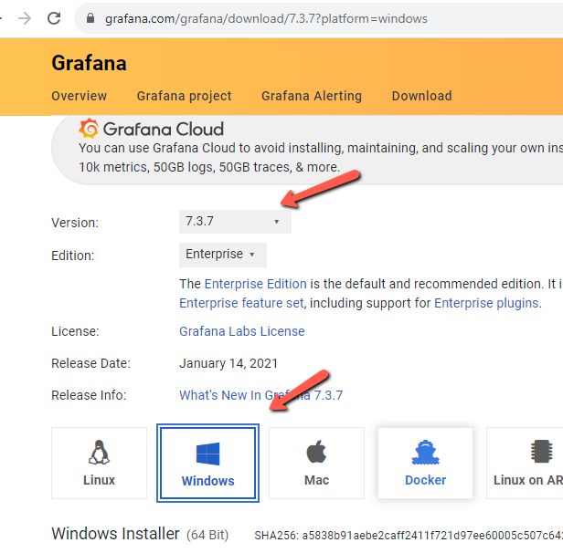

Fig 3.0

**Step 2:** Configure Grafana

* The Grafana backend has a number of [configuration options](https://grafana.com/docs/installation/configuration/) defined in its **config** file (usually located at /etc/grafana/grafana.ini on Linux systems).

**Step 3:** start Grafana Application file, Double click on Grafana-server as shown in below Fig 3.1

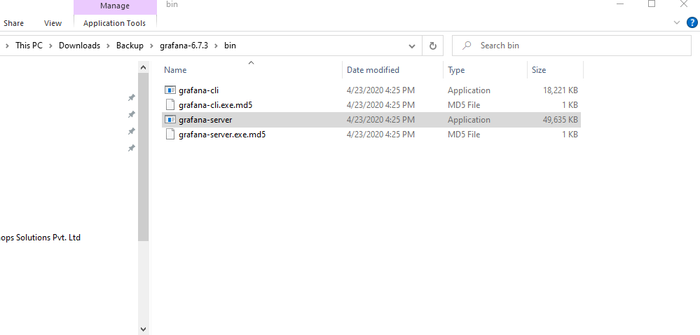

Fig 3.1

OR

**Start Server:**

Open cmd from /bin path

Give command “start Grafana-server.exe”, as shown fig3.2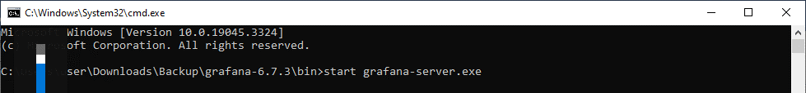

Fig 3.2

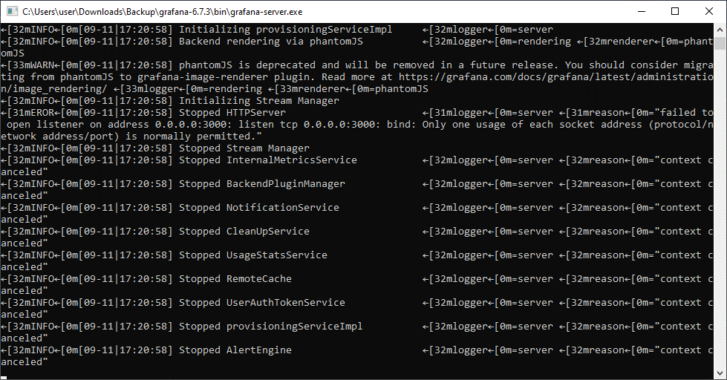

**Step 4:** Open Grafana UI in Browser

1. As soon as the server initiates, you can launch Grafana in your choice of Browser. The tool listens to the **port 3000**>> http://localhost:3000/ (Fig 3.3)

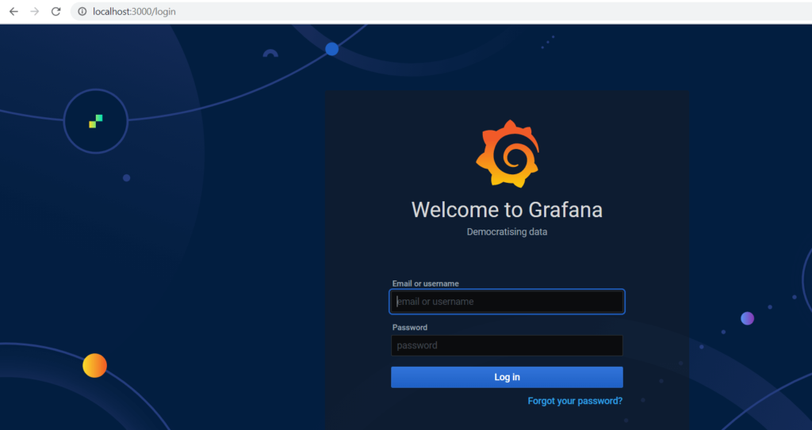

Fig 3.3

Use Credentials: Username: admin /Password: admin

**Step 5:** Add Data Source

1.Go to configurations.

2.Click on Add data source

3.select or search for influx DB as shown in fig 3.4

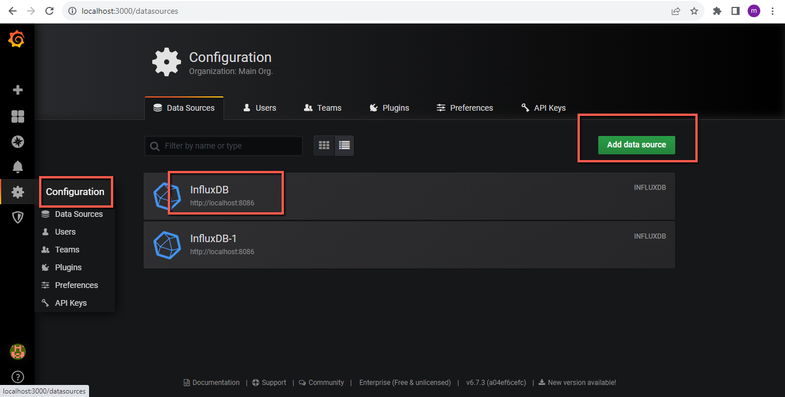

Fig 3.5

4. It opens settings

* Check Name
* Check URL as per given in fig 1.5 if not paste the url from Jmeter to here.
* Provide Data Base Name “JMeter_Demo” in Influx DB Details
* Select HTTP Methods-> GET
* After providing details, click on Save and text
* Select backend time interval 5S
* AS per shown in below fig 3.6.1 and 3.6.2
* It should pop up a tiny Connection successful.



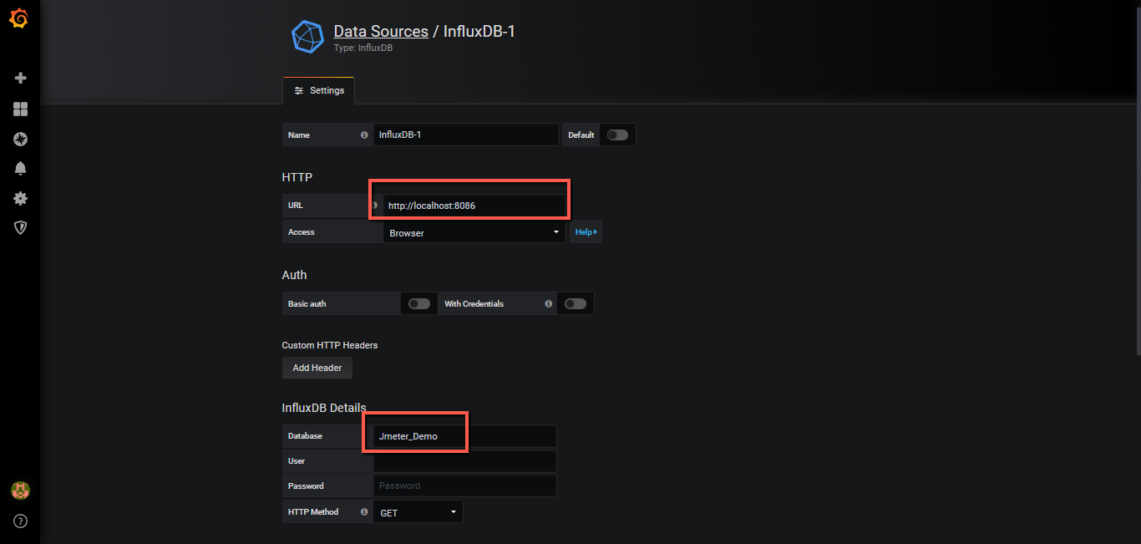

Fi g 3.6.1 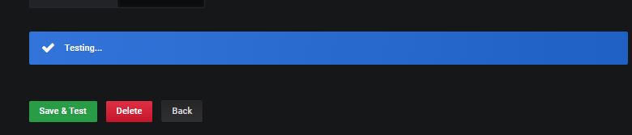

Fig 3.6.2

**Step 6:** create First Grafana Dash Board

1. Go to create (+)
2. Click on import
3. Type Dashboard ID 5496

Note: We are going to choose [Apache JMeter Dashboard using Core InfluxdbBackendListenerClient](https://grafana.com/grafana/dashboards/5496) by Philippe M. copy the dashboard ID: **5496**.

1. Click on load

Ref the fig 3.7

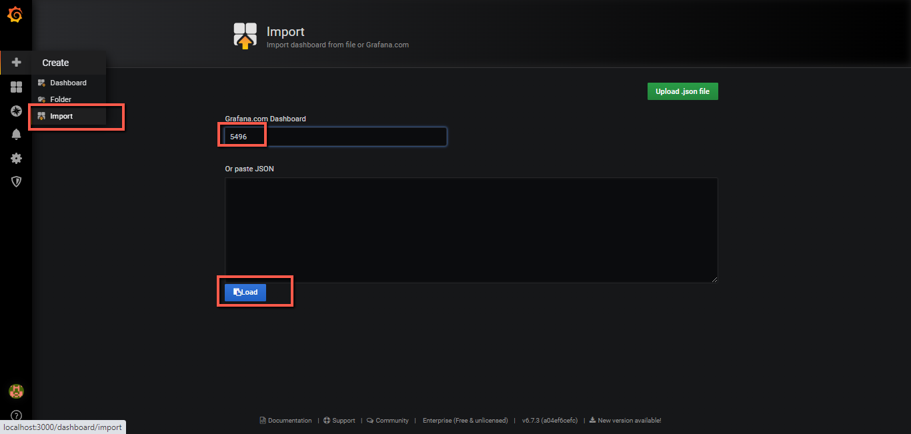

Fig 3.7

**Step 7:** it shows gig 3.8 after load the dashboard

* Provide name as per you are wish
* Select General Folder
* Select the Data Base Name as shown in Fig 1.5(URL)
* Click on Import( as per shown in Fig 3.8)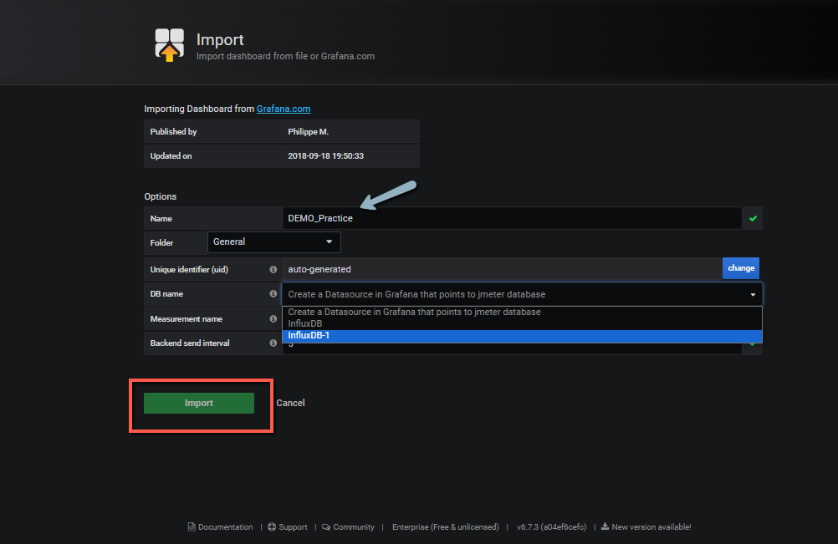

Fig 3.8

**Step 8:** Open the summary report after you Import the Dashboard

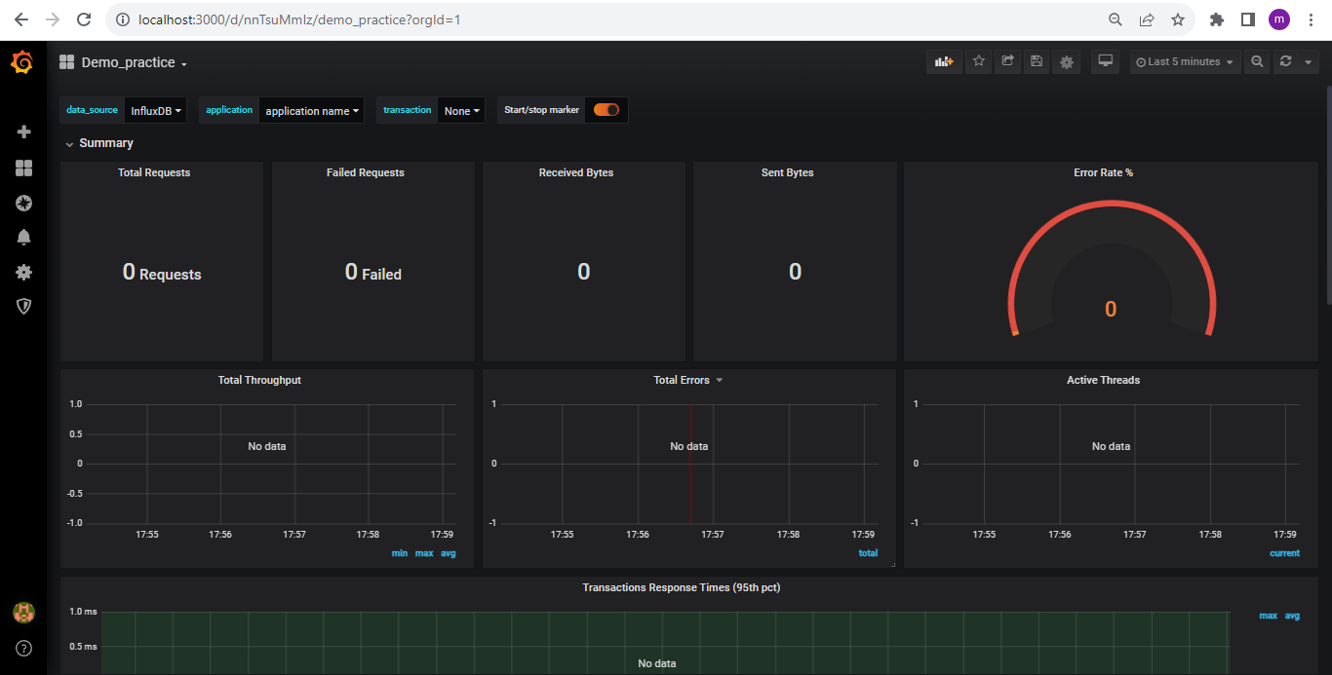

Fig 3.9

* Now we can run our JMeter test and result observed here as a real Time Monitoring system

This is the report generated by me Using JMeter Integration with Grafana and Influx DB

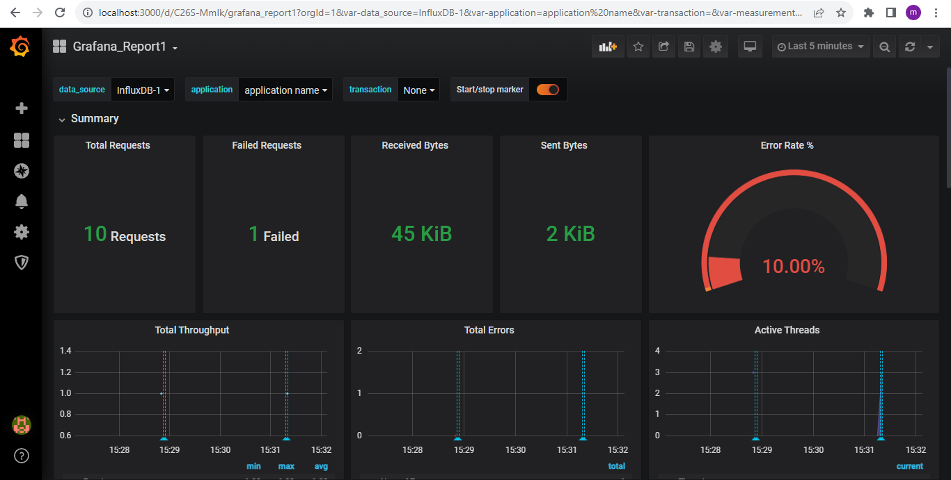

Thank you